Ryley Burnett

Assignment 1.1

Location: A mountainside trail in Eastern Europe leading to open countryside plains that are surrounded by hilly forests.

Timeline: Early 20th Century, around WW1. In an alternate reality with 100ft tall, diesel-powered mech robots.

Player: You play as a larger-than-life soldier who carries around heavy artillery and wears a WW1 style gas mask. You have a boston dynamics WILDCAT “dog” who acts as your sidekick and helps carry your equipment.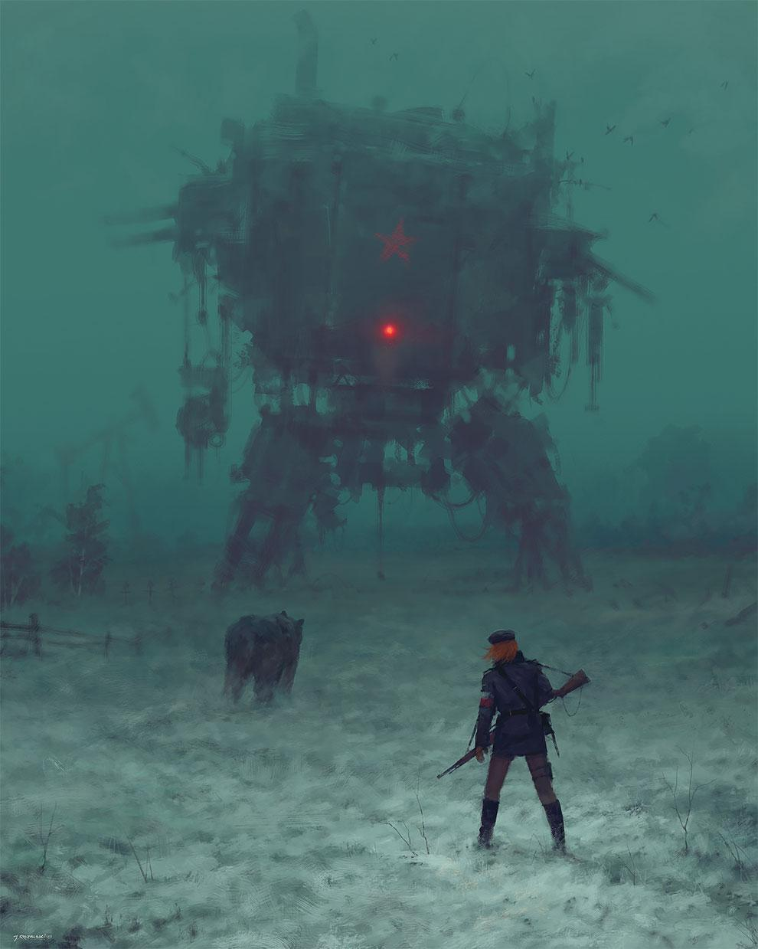

Rescued: Rather than rescuing someone, your goal is to capture a war general who pilots a massive 100 foot mech. He has a cigar, a huge mustache and wears enemy militant gear.

Enemy: Before fighting the mech, you must sneak around the perimeter of a log cabin and take out foot soldiers silently. Then as you fight the mech, it fires capsules from all over its body which land on the ground. These contain normal foot soldiers, heavy artillery troops, trained dogs, and perhaps mini, piloted biped mechs. The mech will open hatches and fire a dozen guided rockets at you. It will also fire its fists at you, attempt to crush you, and may even shoot noxious gas capsules at you.